CS 347
The Duke Depot
Final Report

Team 3: Aaron Zamecnik, Chris Brinkmann, and Charles Humphries
12/02/2014

I. Technical Overview

Implementation Details & Design Changes:

Revised Component Diagram:

Revised Deployment Diagram:

Figure 2:
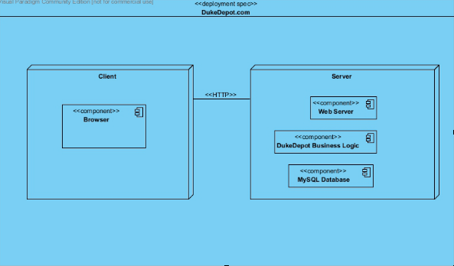

Figure 2 is a Deployment Diagram for the Duke Depot website. The browser resides on the client side, while the business logic and MySQL Databases reside on the server side.

Revised Database Tables:

II. Retrospective & Process Improvement

